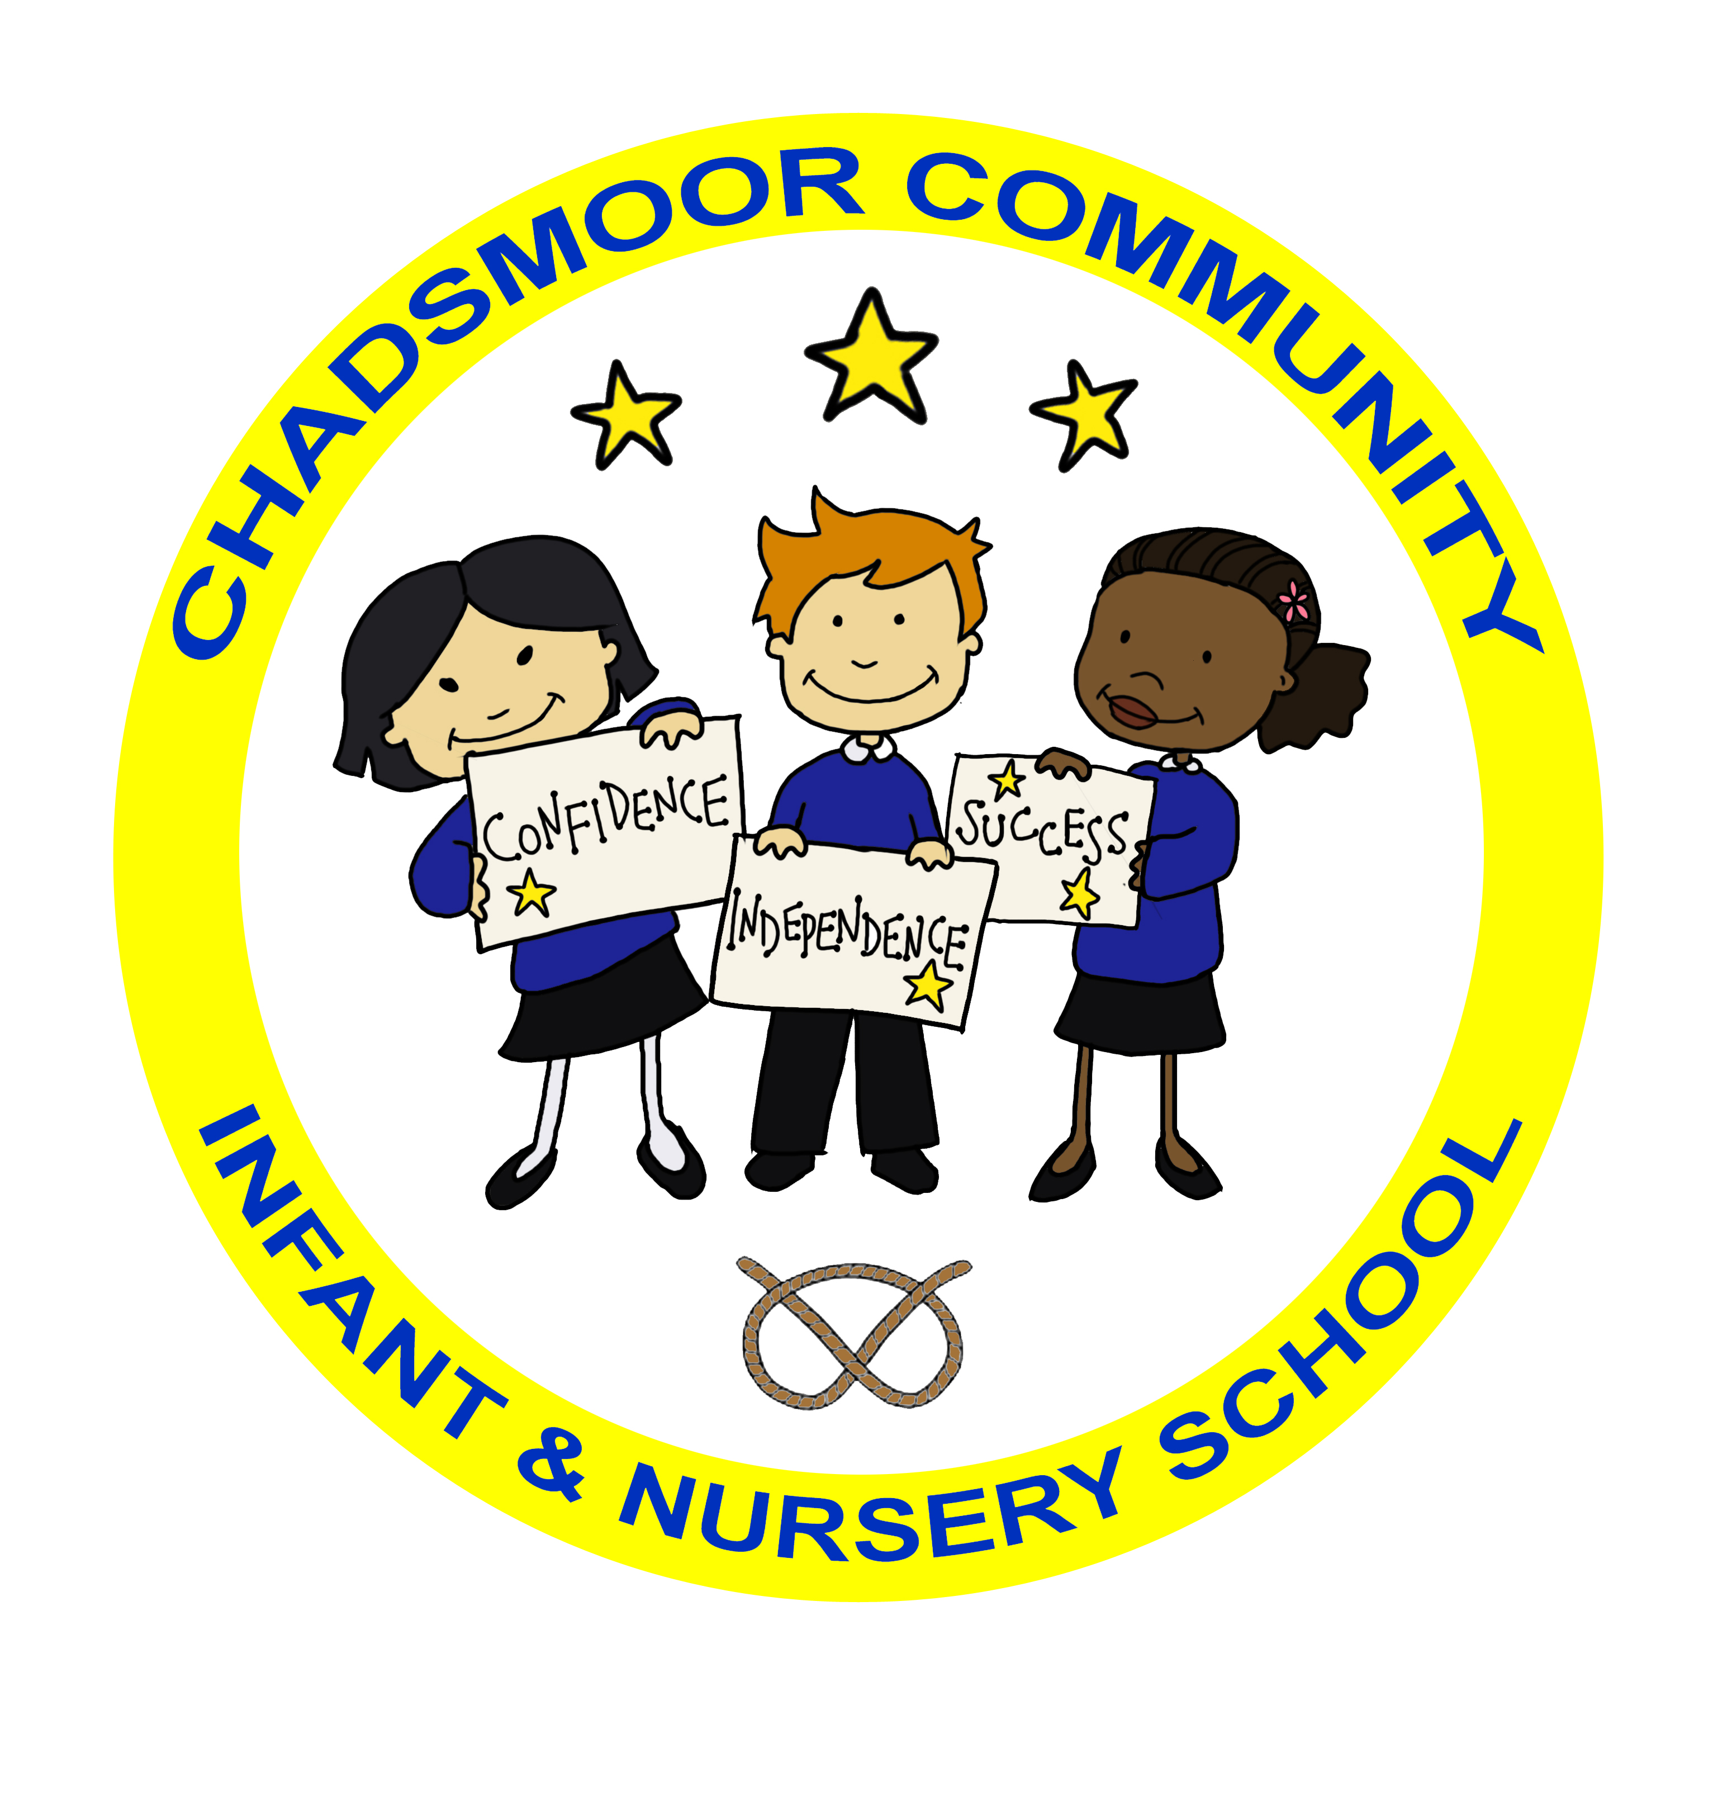
CHADSMOOR COMMUNITY INFANT & NURSERY SCHOOL

APPLICATION FORM

Surname of child:

Forenames:

Date of Birth: |  |  | Sex:
Home Address:

Postcode:

Home Telephone:

Parent/Guardian living with child:

 | Name: (Mrs/Mr/Miss)  Mobile No:  Email: |  |  | Work Address and Telephone:
 | Relationship to the child: (mother/father) |  |  | National insurance number:
 |  |  |  | D.O.B:
 | Name: (Mrs/Mr/Miss)  Mobile No:  Email: |  |  | Work Address and Telephone:
 | Relationship to the child( mother/father) |  |  | National insurance number:
 |  |  |  | D.O.B:
Names of older brothers/sisters within the Federation:

Ethnic Group: |  | Religion: |  |  | Language spoken at home:
Place of Birth: |  |  | Nationality:
OFFICE USE ONLY  Birth Certificate seen YES NO  Initial |  |  | Father named on B.C. YES NO  Name ……………………………………….

Previous Educational Experiences:
Playgroup: | From: | To:
Nursery: | From: | To:
School: | From: | To:
Travel Arrangements:

Walk Bus Car/Van School Bus

Taxi Train Car share with other child/children

MEDICAL INFORMATION Doctor (Name, Address & Tel):

Is your child left or right handed?

Does your child: Yes No

If yes, please give details

Suffer from epilepsy □ □ …………………………………..

Suffer from diabetes □ □ ……………………………………
Suffer from asthma □ □ …………………………………..
Suffer from eczema □ □ …………………………………..

Wear glasses □ □ …………………………………..
Food allergies or any food allergies/intolerances □ □ …………………………………..
Have any special dietary needs □ □ …………………………………..
Have a speech problem □ □ …………………………………..
Attend speech therapy □ □ …………………………………..
Have any other physical problems □ □ ………………………………….
Have any Special Educational Needs (SEN) □ □ …………………………………..
Have any EHCP □ □ …………………………………..

Has your child had any infectious diseases?

Measles Mumps German Measles Chicken Pox
Scarlet Fever Other

Has your child had injections for

Diphtheria Tetanus Whooping Cough Polio
Measles Meningitis Other

Additional Emergency Contacts

Please list below any other daytime emergency contacts (in priority order) other than parents listed on the Admission Form. For example, any relative, neighbour, etc, known and trusted by and your child.

3. | Title: (Mr/Mrs/Miss) | 4. | Title: (Mr/Mrs/Miss)
Surname:  Forname:  Address (Work/Home):  Postcode:  Tel:  Mobile:  Relationship to child: |  | Surname:  Forname:  Address (Work/Home):  Postcode:  Tel:  Mobile:  Relationship to child:
5. | Title: (Mr/Mrs/Miss) | 6. | Title: (Mr/Mrs/Miss)
Surname:  Forname:  Address (Work/Home):  Postcode:  Tel:  Mobile:  Relationship to child: |  | Surname:  Forname:  Address (Work/Home):  Postcode:  Tel:  Mobile:  Relationship to child:

Parental Responsibility

CHADSMOOR COMMUNITY INFANT & NURSERY SCHOOL

A GUIDE FOR PARENTS

What is Parental Responsibility (PR)?

Parental Responsibility means having the right and responsibility to make important decisions in the life of a child. Decisions like:

- Where they live.
- Where they go to school.
- What medical treatment they receive.

This factsheet is about Parental Responsibility and Schools. If a school knows all the people who have Parental Responsibility for a child then they can make sure that they keep them informed about that child’s educational progress.

Who has Parental Responsibility (PR)?

A child’s mother ALWAYS has Parental Responsibility. She can only lose it if her child is adopted by someone else. Other people can share Parental Responsibility including:

- Fathers married to the mother at the time the child was born
- Fathers who are not married to the mother, but are registered on the child’s birth certificate. The registration or re-registration must have taken place after December 2003
- Civil partners and partners of mothers registered as the child’s legal parent on the birth certificate

The situation for an unmarried father is more complicated and depends on when the child was born. If a child was born before December 2003 unmarried fathers can get Parental Responsibility by:

- Marrying the mother of the child.
- Registering a Parental Responsibility agreement with the court applying for a court order granting them Parental Responsibility.

Other Parents

Parental Responsibility

There are some people who are legally seen as parents but who do not have Parental Responsibility. Anyone who has the day to day care of a child is seen as a parent. They are expected to make sure that:

- The child receives an education.
- They are fed and cared for appropriately.
- They have to look after their children as much as a person with Parental Responsibility. The main difference is that the person with Parental Responsibility will have the final say in the important decisions mentioned above. If they fail to look after their children they will be treated in the same way as a person with Parental Responsibility who fails in these duties. For example: if a child does not go to school regularly, then all parents, whether they have Parental Responsibility or not, can be prosecuted and could be fined.
Schools and Parental Responsibility

Please keep your child’s school informed about any changes in your family circumstances. If schools are told about the changes then we can keep everyone up to date about how their children are getting on.

Families sometimes have difficulties, and courts can become involved in the care and living arrangements of the children. In these cases schools need to know about Court Orders that have been made. If you are not sure if the information will be useful you can arrange to talk in confidence to someone at school.

_________________________________________________________
Further Information
For general information about the contents of this factsheet please contact your local Education Welfare Officer:
Lichfield and Cannock
District Educational Welfare Office
TELEPHONE: (01543) 512050
If you have a specific query about Parental Responsibility you might find it useful to contact; a solicitor, legal centre or:
Citizens Advice Bureau
48 Allport Street, Cannock, Staffordshire, WS11 1DY
TELEPHONE (01543) 502236

Chadsmoor Community Infant & Nursery School

Child’s Name________________________D.o.b______________________
Address_____________________________________________________
___________________Postcode________________Tel:_______________

PLEASE READ THE ENCLOSED LEAFLET CAREFULLY BEFORE COMPLETING THIS FORM

- The following adults live with the child and act as parent:

Full Name | Relationship to child | Do they have  Parental Responsibility
 |  | YES/NO
 |  | YES/NO
 |  | YES/NO
 |  | YES/NO
 |  | YES/NO

- The following adults have “Parental Responsibility” but do not live with the child:

Full Name | Relationship to child | Address

- Are there any Court Orders which relate to the child? E.g. custody orders/Section 8 Orders under the Children Act 1989 YES/NO

If YES please say what they are:

This information will be transferred into the school’s computer system. Under the Data Protection
Act 1984, anyone named above has the right to know that information about them has been collected and given an opportunity to check its accuracy.

This form should be signed by someone with Parental Responsibility wherever possible.
Please return it to school as soon as possible.

Signed___________________________Relationship to child____________________________

Date____________________________________________

CHADSMOOR COMMUNITY INFANT & NURSERY SCHOOL

PERMISSION SLIPS INFORMATION
for new admissions

Educational Visits
These are linked to curriculum areas to enhance the children’s education. We do try to keep costs to a minimum and insurance costs are met by the school. However, coach fares and entrance fees have to be paid for by donations from parents. Visits will be cancelled if there aren’t sufficient donations to meet these costs. Payment may be made by instalments, providing that we receive the money in full before the day of the visit. If parents have difficulties in meeting these costs they should speak to the Headteacher.
We have to ask for permission from parents to take the children off school premises. This is usually requested when individual trips are arranged, however sometimes we may wish to take the children out locally, i.e. looking at different houses, street signs, churches, etc. (the insurance paid by school does cover such visits). We would be grateful if you could sign the PERMISSION SLIPS form allowing us to take your child on these short visits.

Photographs
From time to time we take photographs of children to be used as a record of pupil’s progress in subjects or as a record of activities taking place in school and to promote the work of the school in the local media and on the school website. We are sometimes approached by Staffordshire County Council to take photographs of children to promote education within Staffordshire. We are required to ask all parents permission. Would you please sign the PERMISSION SLIPS form and return if you agree.
A copy of the school’s policy for safe use of photographs is available on the school website www.chadsmoor-infants.staffs.sch.uk or by request from the school office.

Responsible Internet Use

As part of your child’s curriculum and the development of ICT skills, Chadsmoor Community Infant & Nursery School is providing supervised access to the Internet. We believe that the use of the World Wide Web and e-mail is worthwhile and is an essential skill for children as they grow up in the modern world. Please would you read the enclosed ‘Acceptable Use Policy Agreement’ document, and sign and return the consent on the PERMISSION SLIPS form so that your child may use the Internet at school.

Although there have been concerns about pupils having access to undesirable materials, we are taking positive steps to deal with this risk in school. Our school Internet provider operates a filtering system that restricts access to inappropriate on materials. This may not be the case at home and we can provide references to information on safe Internet access if you wish. We also have leaflets from national bodies that explain the issues further.

Whilst every endeavor is made to ensure that suitable restrictions are placed on the ability of children to access inappropriate materials, the School cannot be held responsible for the nature or content of materials accessed through the Internet. The School will not be liable for any damages arising from your child’s use of the Internet facilities.
Should you wish to discuss any aspect of Internet use please contact me to make an appointment when our ICT technician is available.
_______________________________________________________________________________________

ClassDojo

ClassDojo is a communication app for the classroom. It connects teachers, parents, and students who use it to share photos, videos, and messages through the school day. They use ClassDojo to work together as a team, share in the classroom experience, and bring big ideas to life in their classrooms and homes.

CHADSMOOR COMMUNITY INFANT & NURSERY SCHOOL

PERMISSION SLIPS

Please read all the notes on the Permission Slips Information sheet before signing this form.

CHILD’S NAME …………………………………………………… DATE ………………………

Parent / Carer’s Consent for Local Visits
I have read and understood the Educational Visits information and I give permission for my child to make local visits as and when arranged.

Signed………………………………….…………….(Parent/Carer) Please print name………………….………

Parent / Carer’s Consent for Photographs/Videos
From time to time we take photographs of children to be used as a record of pupil’s progress in subjects or as a record of activities taking place in school. We are required to ask all parents permission. Children may also appear on the website or in local Newspapers from time to time. Would you please delete where appropriate and sign the declaration.

I agree / do not agree to my child being photographed for:
I agree/ do not agree to my child being filmed for:

school activities / for the school prospectus / newspapers / for use on the school website/ClassDojo
(please delete as necessary)
(I understand that no website photograph will be labelled with the name of the child.)

I understand that any photographs or videos taken at school events will be for private retention only and not published in any manner including use on personal websites or social networking sites.

Signed………………………………….…………….(Parent/Carer) Please print name………………….………

Parent / Carer’s Consent for Internet Access
I have read and understood the school ‘Acceptable Use Policy Agreement’ document and give permission for my son/daughter to access the school’s ICT systems and the Internet. I understand that the school will take all reasonable precautions to ensure pupils cannot access inappropriate materials. I understand that the school cannot be held responsible for the nature or content of materials accessed through the Internet. I agree that the school is not liable for any damages arising from use of the Internet facilities.

Signed………………………………….…………….(Parent/Carer) Please print name………………….………

Attendance Policy & Behaviour Policy
I have read and understood the Policy for Attendance and the Policy for behaviour at Chadsmoor Infants & Nursery school, and agree to support the school in its implementation of these policies.

Signed………………………………….…………….(Parent/Carer) Please print name………………….………

Emergency Medical Treatment / Personal Care
I give permission for school to seek any necessary medical advice or treatment for my child.
I give permission for my child to be changed in the event of a toileting accident.

Signed…………………………………………….. (Parent/Carer) Please print name…………………….……………………….
PTO

Parent/Carer’s consent for cooking
As part of the Foundation Stage Curriculum, your child will be taking part in a range of activities which include handling, tasting and cooking food. We feel it is important that children are introduced to a range of different foods, encouraged to eat healthily and to experience and explore foods. This will encourage children to use all their senses, develop an awareness of other cultures and have a positive approach to new experiences. Using food can develop skills in all areas of learning, for example measuring ingredients is maths, using utensils develops fine motor skills, following recipes and instruction is part of reading.

Is there any food that your child cannot or that you would prefer them not to eat?

Please give details…………………………………………………………………

I give permission for my child to take part in cooking activities.

Signed…………………………………………….. (Parent/Carer) Please print name…………………….………

MESSAGES
IF YOUR CHILD IS COLLECTED BY ANYONE OTHER THAN A PARENT, ARE YOU HAPPY FOR ANY MESSAGES (INCLUDING DISCIPLINARY ISSUES) TO BE PASSED ON TO THE PERSON WHO IS COLLECTING YOUR CHILD (E.G. CHILDMINDER/GRANDPARENT/FRIEND)
yes / no

DECLARATION

ALL OF THE INFORMATION PROVIDED ON THIS FORM IS ACCURATE TO THE BEST OF MY KNOWLEDGE.

Signed…………………………………………….. (Parent/Carer) Please print name…………………….………

CHADSMOOR COMMUNITY INFANTS’ SCHOOL

Home – School – Child Agreement

Child’s Name ………………………………………………………………

Mission Statement:

We support and extend the potential of children and celebrate their learning and achievements. At Chadsmoor Infants School we will encourage children to become confident, independent and successful.

School will:

- Provide a caring, safe and structured learning environment for all children.

- Nurture the development of the whole child.

- When appropriate, inform parents of what the teachers aim to teach the children.

- Inform parents of their child’s progress at regular meetings.

- Be open and welcoming to our children’s families.

Head Teacher’s signature

Family will try to:

- Make sure the child arrives at school on time: 8.50 am.

- Make sure the child attends regularly and provide an explanation if the child is absent.

- Inform the school of home circumstances which may affect the child.

- Attend meetings to discuss the child’s progress.

- Encourage the child to wear school uniform, as it gives a sense of pride in belonging to Chadsmoor Infants School.

Parent’s signature

P.T.O

Child:

- I will be polite and kind to others.

- I will talk quietly and listen.

- I will behave well in school.

- I will walk around school.

- I will take good care of everything at school.

Child’s signature

Together we will:

- Support the child’s learning to help them achieve their best.

- Encourage the child to behave well at school and in the community.

- Tackle any difficulties which may arise.

CHADSMOOR COMMUNITY INFANT & NURSERY SCHOOL

People who can collect my child from school

Child’s Name ……………………………………………………………… Class Teacher ………………………………………………………

Name of person/people who will regularly collect my child – include yourself | Name by which child refers to them (e.g. Mum, Dad, Nanny, Uncle Jim)
Name of person/people who may occasionally collect my child | Name by which child refers to them (e.g. Aunty Sarah, Uncle Jim, nickname etc)

If you wish to update this list at any time, please speak to your child’s class teacher.

Signed ……………………………………………………………………………….. Date ……………………………………………………..
(person with parental responsibility)

Your Name (please print) …………………………………………………………………………………….

Relationship to child ………………………………………………………………..…………………………..

Please note if someone else collects your child who is not on the list, school will ring and check with yourselves. This could mean a slight delay in your child leaving school.

