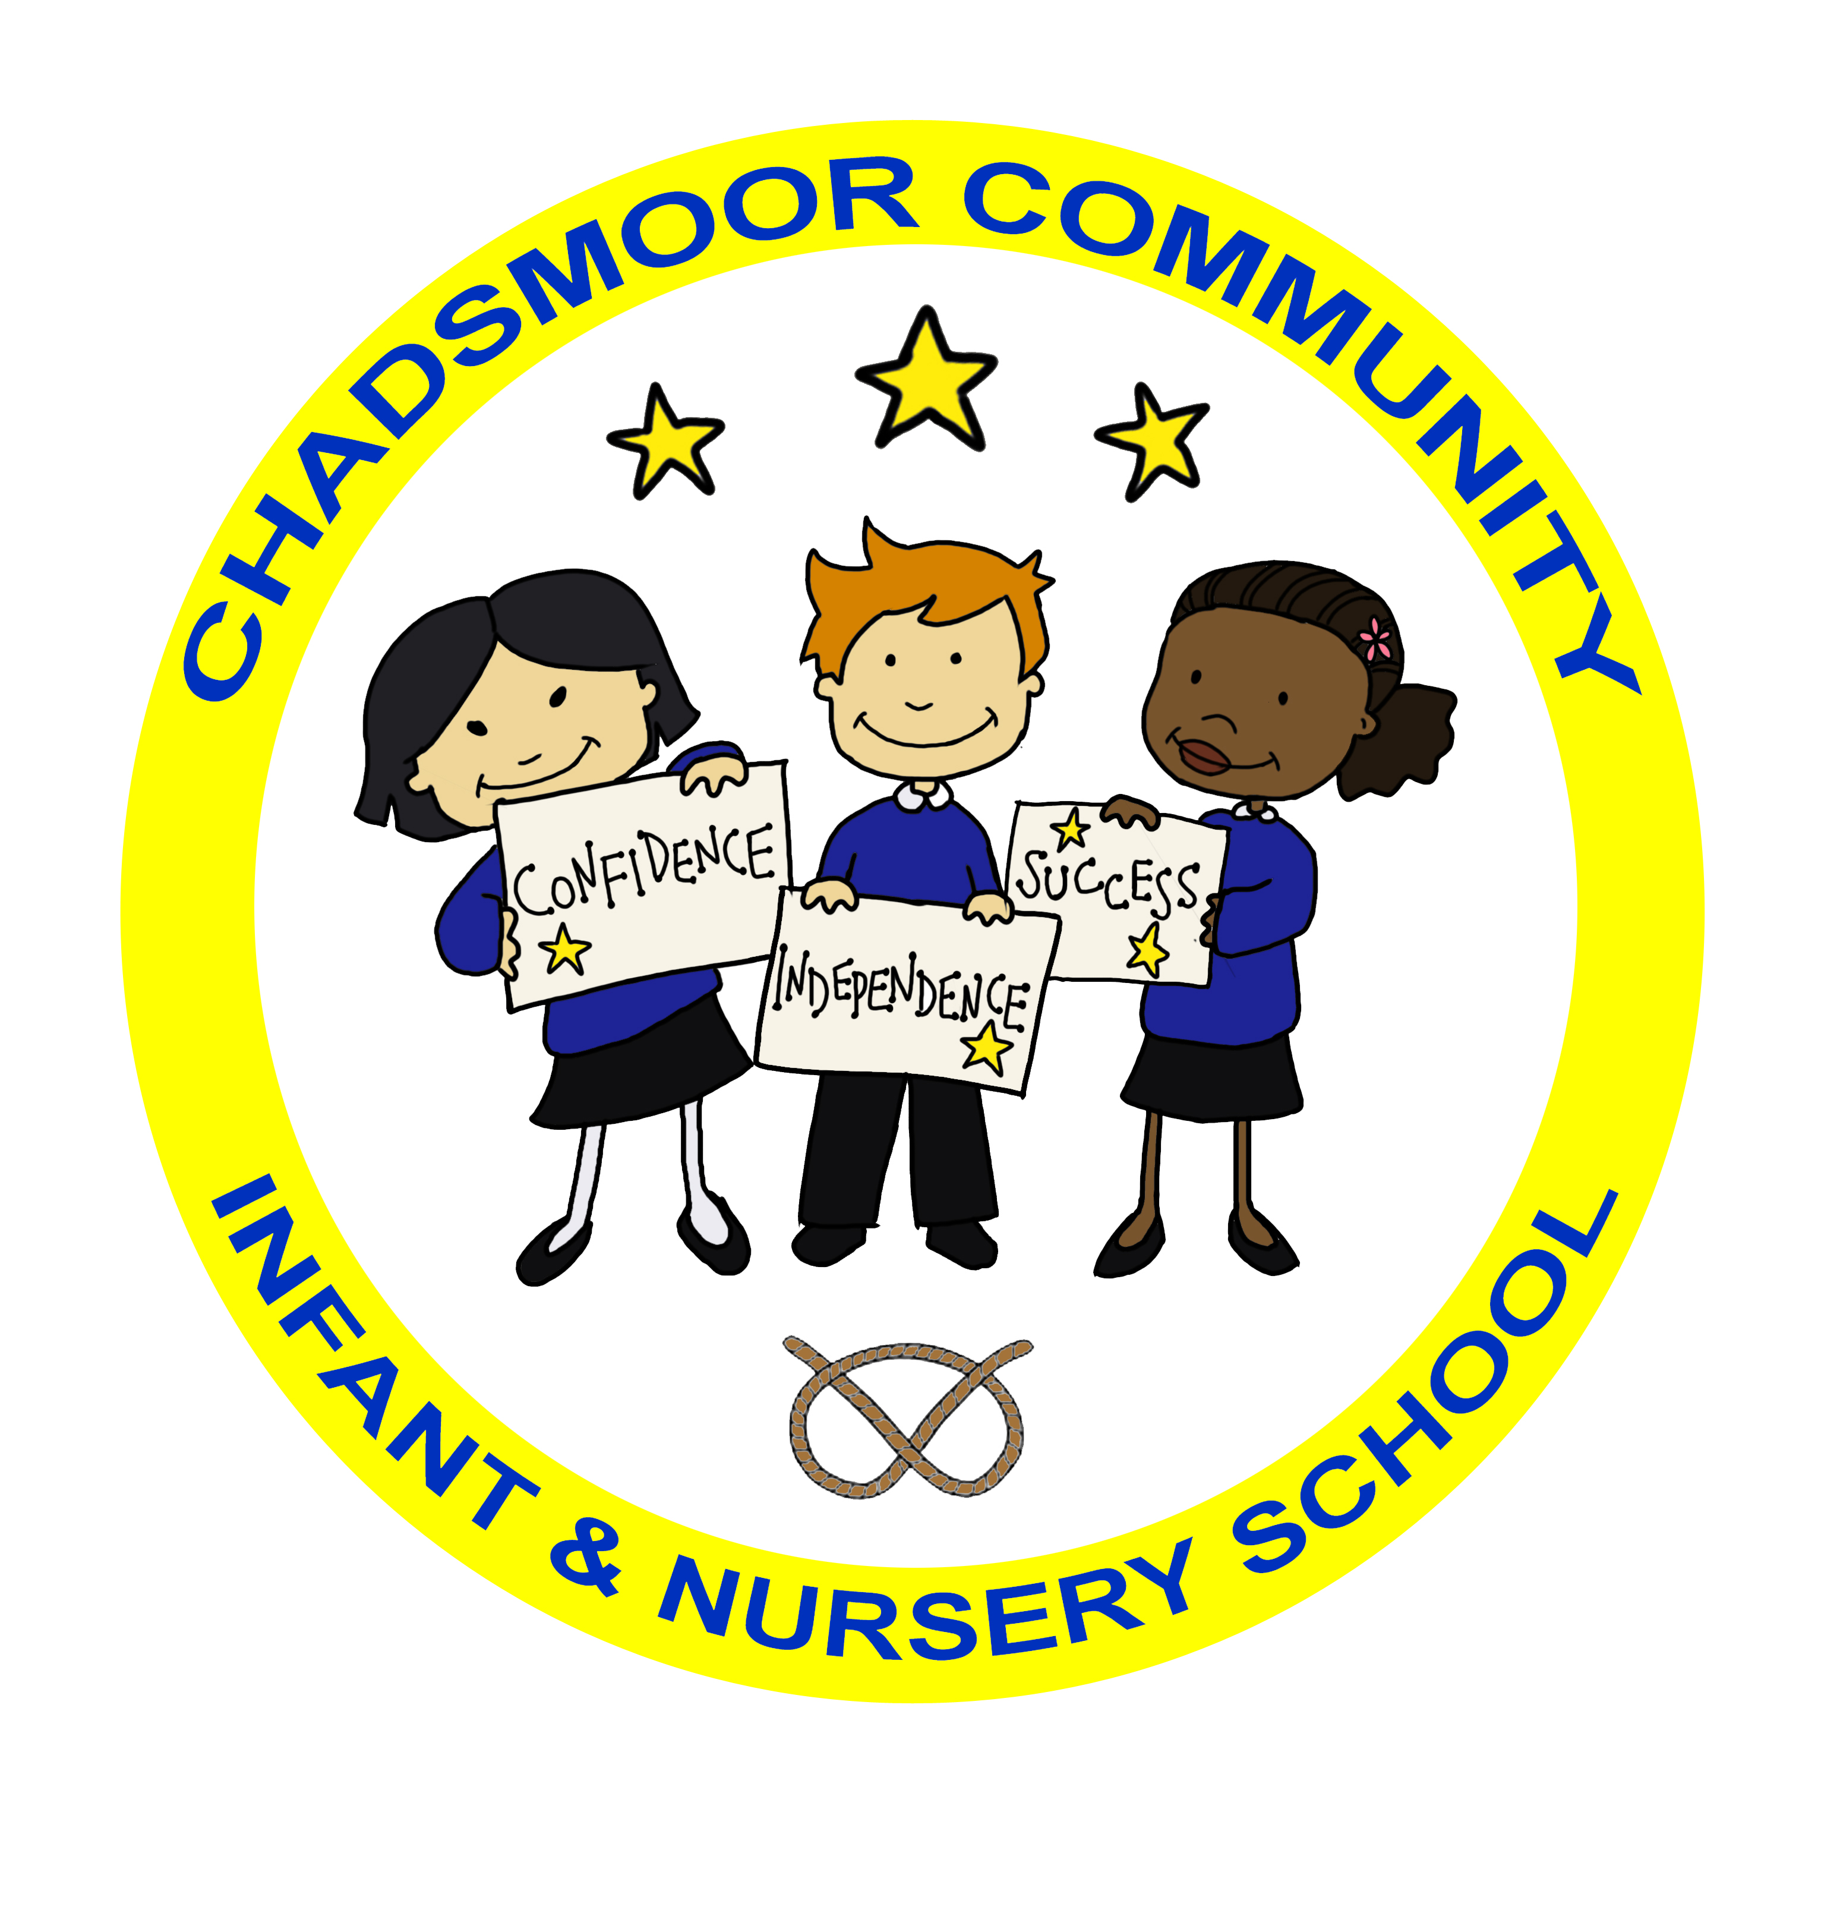
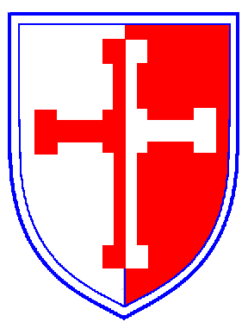
The Federation of
Chadsmoor Community Infant and Nursery School
and
Chadsmoor C.E (VC) Junior School

Executive Headteacher: Mrs J Westley (BA (Hons) QTS, NPQH)
Email: infantoffice@chadsmoorfed.staffs.sch.uk
Website: www.chadsmoor-infants.staffs.sch.uk
Kingsway, Chadsmoor, Cannock, Staffs. WS11 6EU
Telephone 01543 570718

Email: junioroffice@chadsmoorfed.staffs.sch.uk
Website: www.chadsmoor-junior.staffs.sch.uk
Burns Street, Chadsmoor, Cannock, Staffs, WS11 6DR
Telephone: 01543 227200

Dear Parents/Carers,

As part of our Jigsaw PSHE scheme, during the next half term (Summer Term 2), children in Year 1 will be completing the Changing Me Puzzle Piece which covers the following topics:

- The life cycle of animals (frog spawn, tadpole, frog) and humans (baby in a tummy, baby, child and adult)
- How children have changed since they were a baby
- The names for their private parts and where they are located.
- That these areas are private.

This is part of Health Education which has been made compulsory in the September 2020 guidance published by the Department of Education.

It is important to teach children the correct terminology for male and female private parts at an early age and that these parts are private and no one has the right to touch them without their permission. These will be introduced through cartoons and social stories to the children which are appropriate for children of their age. Any questions will be answered by staff at an age appropriate level.

Further information can be found on the PSHE section of the Federation’s website.

Yours sincerely,

Miss Curtis
PSHE Coordinator across the Federation

