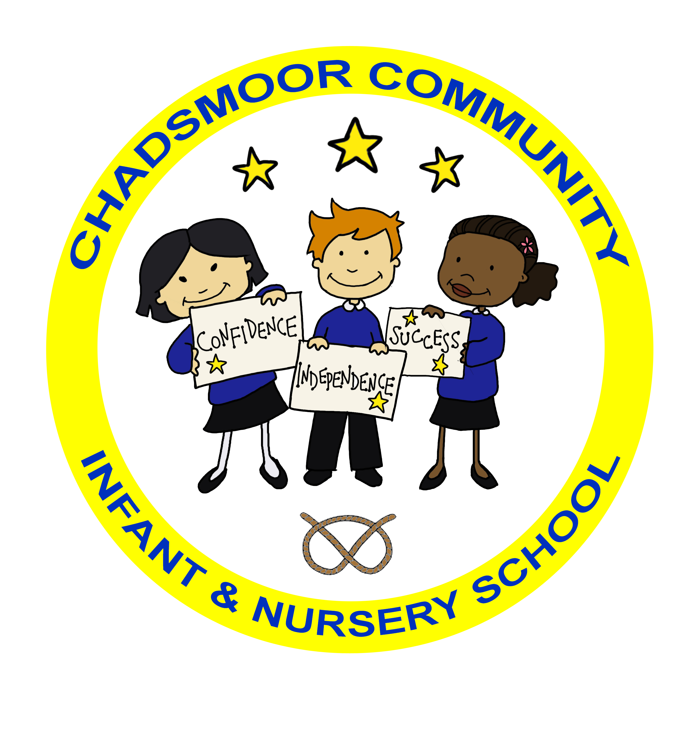

The Federation of
Chadsmoor Community Infant and Nursery School
and
Chadsmoor C.E (VC) Junior School

Executive Headteacher: Mrs J Westley (BA (Hons) QTS, NPQH)
Email: infantoffice@chadsmoorfed.staffs.sch.uk
Website: www.chadsmoorfed.staffs.sch.uk
Kingsway, Chadsmoor, Cannock, Staffs. WS11 6EU
Telephone: 01543 570718

Email: junioroffice@chadsmoorfed.staffs.sch.uk
Website: www.chadsmoorfed.staffs.sch.uk
Burns Street, Chadsmoor, Cannock, Staffs, WS11 6DR
Telephone: 01543 227200


Dear Parent/Carer

At Chadsmoor Juniors we operate the same packed lunch policy as the Infants school and as a health conscious school we encourage parents to provide a healthy lunch for their child. Packed lunches could include:

Sandwiches
Crackers
Cheese
Yoghurts – pots or tubes (not yoghurt drinks)
Raw vegetables
Dried or fresh fruit
1 small biscuit or cake or cereal bar (not chocolate coated or iced)
Bread sticks
A small pack of Baked savoury biscuits or snacks or crisps

Sweets, chocolate covered or iced cakes and biscuits, chocolate bars, crisps (fried), sausage rolls and pies are not allowed.

No flavoured drinks should be included in lunch boxes as we encourage children to bring water bottles (with a sports lid only) into school to use during the day.

We thank you for your co-operation in this matter.

Yours sincerely


Mrs J Westley
Executive Headteacher

A healthy packed lunch could include:
• A good portion of starchy food, e.g. wholegrain roll, tortilla wrap, chapatti,
pitta pocket, pasta or rice salad;
• A portion of lean meat, fish or alternative, e.g. chicken, ham, beef, tuna,
egg, beans or hummus;
• Plenty of fruit and vegetables, e.g. an apple, satsuma, handful of cherry
tomatoes or carrot sticks, small tub of fruit salad or small box of raisins;
• A portion of dairy food, e.g. reduced fat cheese, pot or tube yogurt or fromage frais;

Healthier lunchbox tips
The key to a healthy packed lunch is getting the right balance and choosing a wide
variety of foods, which will help provide all the nutrients children need to grow and
be healthy.

Here are some tips to help you get started:
• Try different breads or other starchy foods for variety e.g. pitta pocket, tortilla
wrap, crispbread, pasta or rice salad.
• Use spread sparingly and go for reduced fat spread or reduced calorie mayonnaise.
• Include brightly coloured fruit and vegetables, e.g. cherry tomatoes, sticks of pepper,
carrot or cucumber, satsuma, grapes or fruit salad.
• Add salad to sandwiches and chopped vegetables to salads.
• Having a healthy lunch does not mean giving up all the foods children enjoy. Foods such as a slice of malt loaf or banana bread, a fruit scone, a small packet of baked crisps
or a biscuit (not chocolate coated or iced) can be included.
Tips to keep food chilled (especially important in hot summer months):
Use an insulated lunch box and chill fruit in the fridge before packing. Try using a
frozen ice block or gel-pack to keep food chilled.

